Sintra Tour, 16th of July
- Pick Up at 13:30 – Rua das Francesinhas, close to entrance 2 of the ISEG campus
- We start our tour by visiting the historical centre of Sintra, where we walk the beautiful old streets in the historical centre, visit the outside of the town hall, the Moorish fountain and the observation towers. You will have an opportunity to take photographs of the National Palace of Sintra and also of the Pena Palace, which is a very extravagant palace built on the top of a 500m high outcrop, with a dominating view along the whole coast to Lisbon.
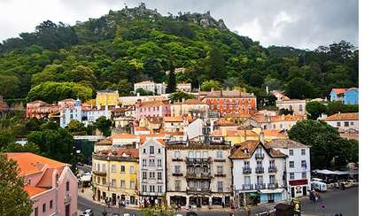
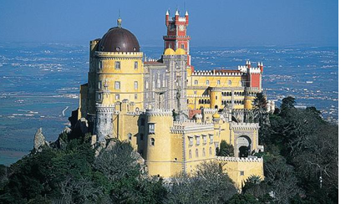
- We then move on to visit the Cabo da Roca, “where the land ends and sea begins”. Massive waves can be seen loudly breaking in the turbulent waters against the 140m high cliffs. There is a beautiful view from here of the wild coastline.
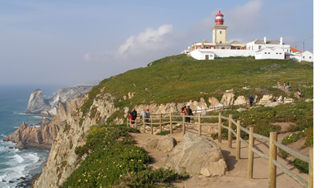
- Passing through the Boca do Inferno (the ‘Mouth of Hell’), we can again see waves smashing against the rocky cliff-face and also hear the impressive roar of the waves in a blow-hole which is reputed to resemble the devil's voice.
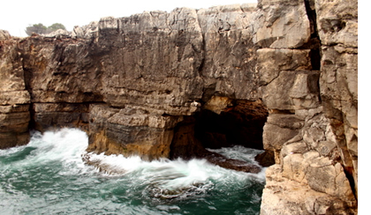
- Finally we visit Cascais – which has been a fishing village since the Twelfth Century and has been well preserved up to this today.
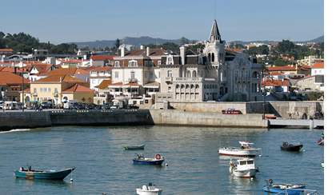
- To end, we return to Lisbon along the coast road, passing by through Estoril on the way, where we can admire the beautiful coast and its beaches.
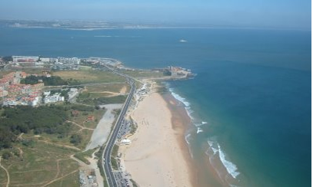
- Drop off at 18.30-19:00, approximately – Rua das Francesinhas, close to entrance 2 of the ISEG campus.

(If you get separated from the main group during the tour, please contact Celina Batista: +351 926 049 232)

